Kidblog

Kidblog can be used by students to express a point of view on a subject and support it with evidence in a safe and supervised online environment.

Creating an Account
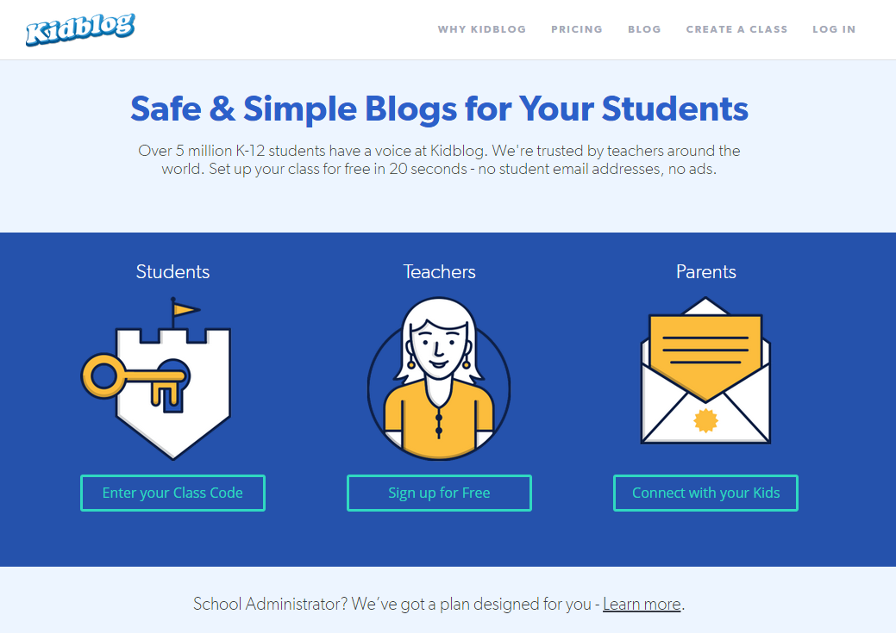
1
Create a teacher account at kidblog.org  - Click on Teachers: Sign up for Free  - Choose a Display Name: this is the name your blog visitors will see.  - Enter a Password and Email address.  - Create a Class Name for your class blog site.  - Click on Create Class. | 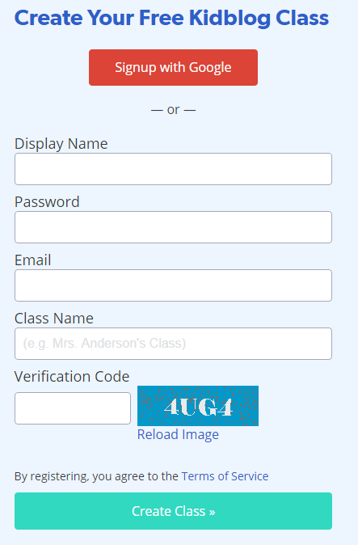  5  4  2  3
Logging on to Kidblog
1a
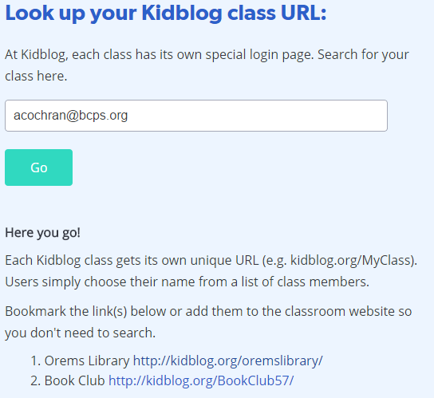
1b
1c
- Type the URL for your class blog site into the Internet address bar.
  - If you don’t know the URL, click the Login tab from the main Kidblog page.
  - Enter the teacher’s username or email and click Go.
  - Select the correct blog link.

2

- In the upper right of the class blog site, click Log In.
- Select your username from the drop-down menu and enter your password.
- Click Log In.
4
3

Kidblog Site Main Page
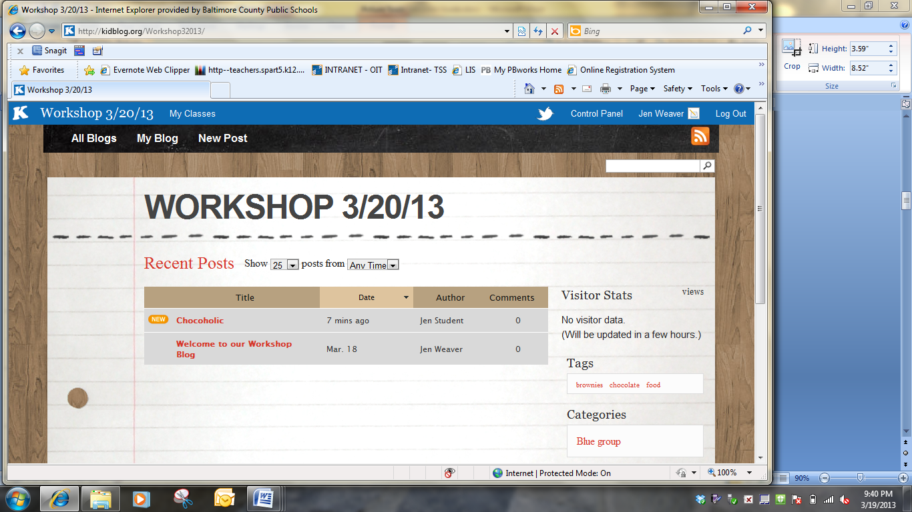
- Switch between class blog sites.
- Displays the site main page.
- Displays your own blog.
- Write a new post for your blog.
- Open the control panel for your class blog site.
- View and edit your profile.
- Search the class blog site.
- List of recent class posts displayed with the newest on top.
- Filter the recent posts.
- Blog site visitor statistics.
- View/filter blogs by tags.
- View/filter blogs by categories.
- Links to other websites.
- Lists members of the class blog.
H
I
N
M
L
K
J
G
F
E
D
C
B
A
Adding a New Blog Post
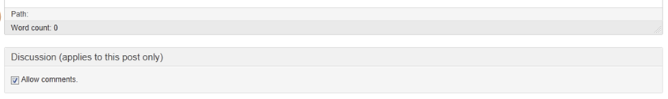
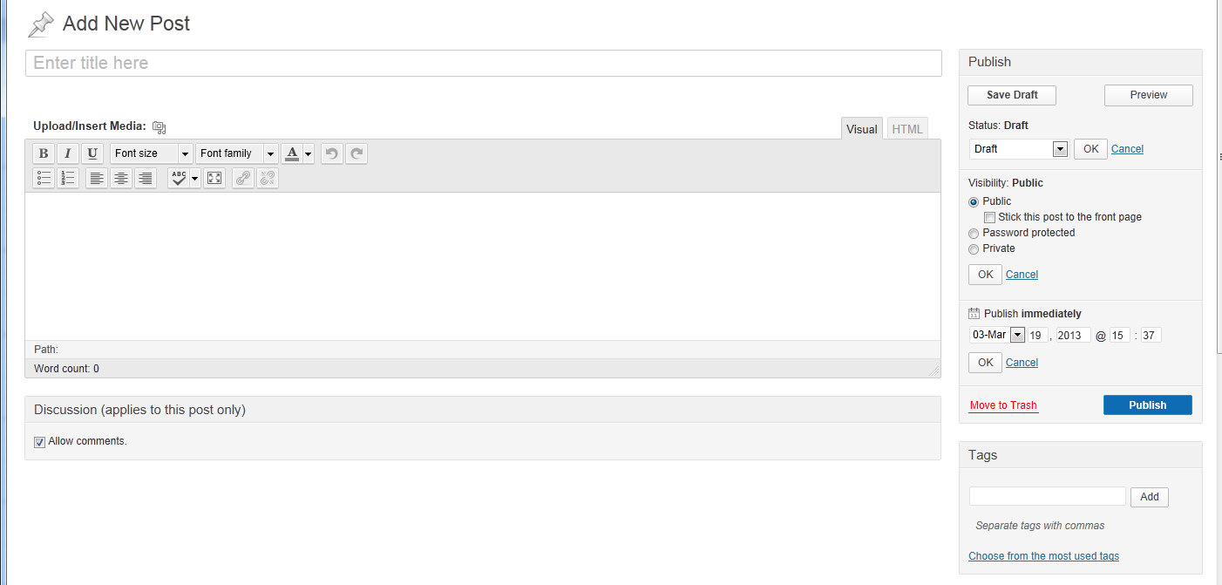
- Give your blog post a descriptive title.
- Enter your text. Use the formatting bar for simple formatting tasks.
- For teachers only- Regardless of site settings, you can disallow commenting on each post.
- Save a draft you aren’t ready to publish.
- Preview your post as it will appear to readers.
- Change your post status.
- Choose who can see your post: Public= all members of the class blog, Password Protected (teachers only)= only members who have the password, Private= only the writer and teachers. Teachers only- stick post to front page so it is always on top of the activity feed.
- For teachers only- Set a time/date to publish or post it immediately.
- Delete the blog post.
- Publish your blog post (pending review if applicable).
- Add tags (keywords) for this post.
- Place the post in an available class category.
- For teachers only- broadcast this post to more than one class blog.
I
C
M
L
K
J
F
G
H
D
E
B
A

Adjusting Class Blog Site Settings
3
2
1
From the Control Panel, select Settings. Use the “tabs” at the top to navigate between the different settings categories. The table below outlines the options for each category.
General | - Change class title and URL  - Find class signup code (for students who already have Kidblog accounts)  - View selected theme  - Choose class avatar  - Set your time zone  - Set the date format
Themes | - Choose a graphic theme for the class blog site
Widgets | - Choose which widgets to include on the sidebar (visitor stats, tags, categories, directory, blogroll)  - Add, edit, and delete tags, categories, and blogroll links
Posts | - Set who can read blog posts  - All visitors (including the general public; no log in necessary)  - Users (class blog members, members of your other classes)  - Admin/Teacher only (good for assessments and private journals; this applies to the whole class blog site- be sure to check “students may read teachers’ posts”)  - Require post approval  - Set teacher email notifications  - Add tags  - Change appearance of Activity Feed on the front page (list and full text views)  - Enable post broadcasting for teachers
Comments | - Set who can leave blog comments  - All visitors (including the general public; no log in necessary)  - Users (class blog members, members of other classes) and/or guests (people who log on with a guest account)  - Admin/Teacher only  - Require post approval  - Set teacher email notifications  - Enable threaded comments and set thread levels  - Enable rich-text comments
Users | - Make user avatars visible  - Define roles:  - Can other teachers create teacher users?  - Can moderators edit/approve posts and comments?  - Can students change their profiles? (This should not be allowed)

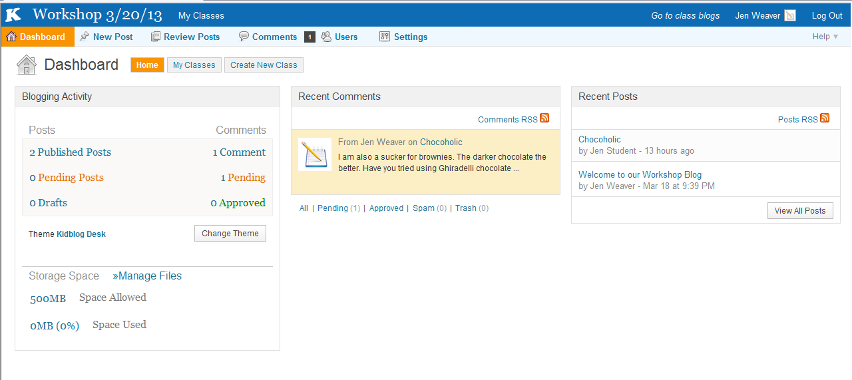
Teacher Dashboard
C
F
E
D
A
B
- Go page to class blog site main page.
- Open other control panel areas (posts, comments, users, and settings)
- Create new classes and edit current classes (view class statistics, join other classes with a code, delete & archive classes)
- Quick view of blogging activity. Click on any of the categories to view more details and actions.
- Quick view of recent comments.
- Quick view of recent posts.
- Manage media files (view, delete, and add files to your media library including MS Office 2003 files, JPG/PNG/GIF images, and PDF files)
G

Student Dashboard
- Go page to class blog site main page.
- Open other control panel areas (posts and comments)
- View classes and join other classes with a code
- Quick view of individual blogging activity. Click on any of the categories to view more details and actions.
- Quick view of recent class comments.
- Quick view of recent class posts.
E
F
D
B
C
A

Adding Users
- From the control panel, select the Users tab.
- Choose one of three options:
  - Add New Users allows you to add individual users one at a time
  - Add Existing Users allows you to add users from your other class(es)
  - Bulk-Create Users allows you to upload a .csv or .txt file with the display names and passwords of multiple users.
Add New Users:
- Enter a Display Name and Password (follow BCPS Protocols for the Use of Online Collaborative Tools for Teaching and Learning)
- Choose the user’s role:
  - Student- can publish posts and leave comments
  - Administrator- full rights and access
  - Teacher- cannot edit Administrator accounts
  - Moderator- can approve/edit posts & comments but can’t alter student accounts
  - Guest- can log in to class blog, but can’t publish posts. May or may not have permission to leave comments.
- Select the class(es) to which the user should be added
1
5
4
3
2

Add Existing Users:
- Select one of your classes from the drop-down menu.
- Check the names of users you want to add to the current class.
- Press the Add button.
8
7
6
Bulk-Create Users:
- Follow the directions to create a .csv or .txt file.
- Click Browse to find the saved file on your computer.
- Select the class(es) to which the users should be added.
- Click Process CSV file.
12
11
10
9

Moderating Posts
- From the control panel, select the Review Posts tab.
- Choose how to view posts: all, by category, or by tags.
- Filter posts by dates, categories, or users.
- Check multiple posts and use the Bulk Actions drop-down menu to approve more than one at a time.
- Use the quick menu below the title of each post to quickly view, edit and approve posts.
- Click on the posts to open and view them.
1
5
3
4
2
Moderating Comments
- From the control panel, select the Comments tab.
- Choose how to view comments: all or only comments on your posts.
- Filter posts by comment types (private or public) or users.
- Check multiple comments and use the Bulk Actions drop-down menu to approve more than one at a time.
- Use the quick menu below each comment for individual approval.
- Click on the comments to open and view them.
1
5
4
3
2

